Deployment of Super Mario on Kubernetes using Terraform

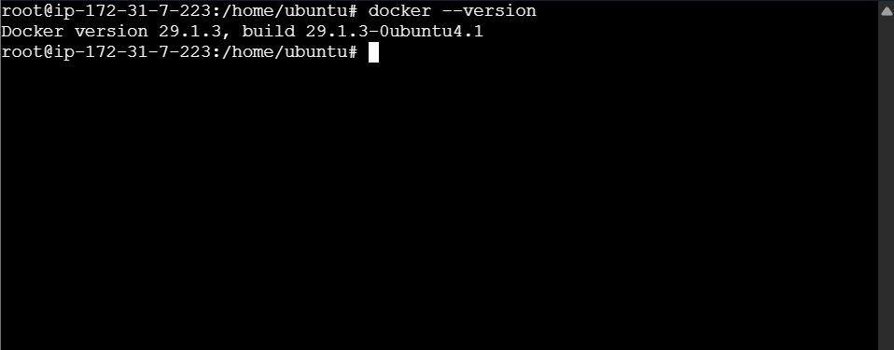

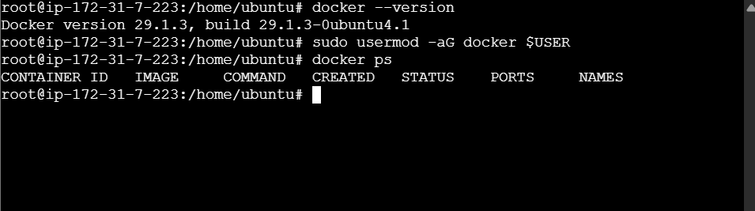

sudo apt install docker.io -y

docker --version

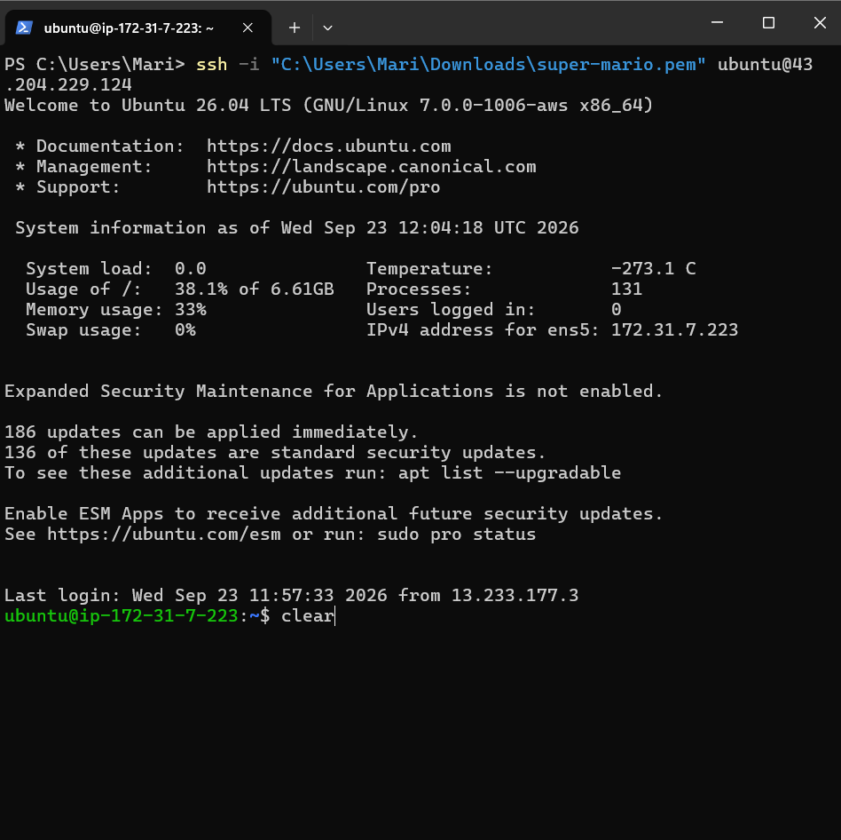

sudo apt install wget -y

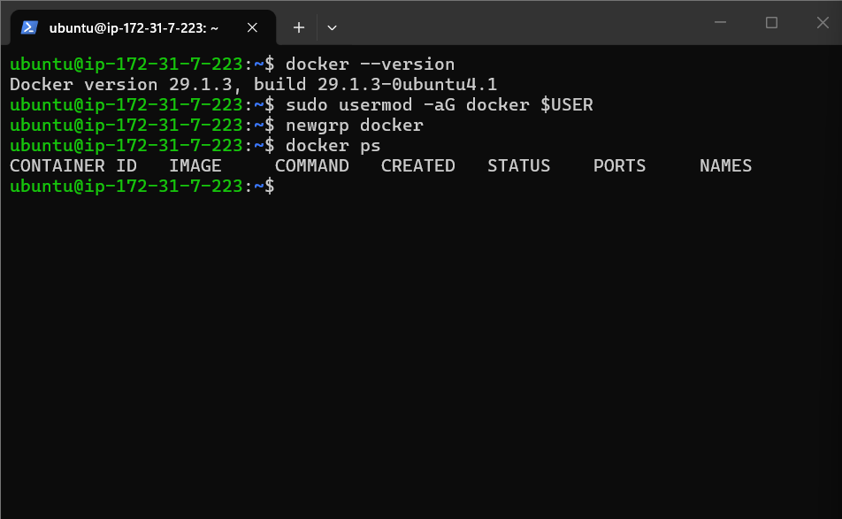

sudo apt install wget -y

wget -O- https://apt.releases.hashicorp.com/gpg | \
sudo gpg --dearmor \
-o /usr/share/keyrings/hashicorp-archive-keyring.gpg

echo "deb [signed-by=/usr/share/keyrings/hashicorp-archive-keyring.gpg] \
https://apt.releases.hashicorp.com $(lsb_release -cs) main" | \
sudo tee /etc/apt/sources.list.d/hashicorp.list

sudo apt update
sudo apt install terraform -y

terraform --version

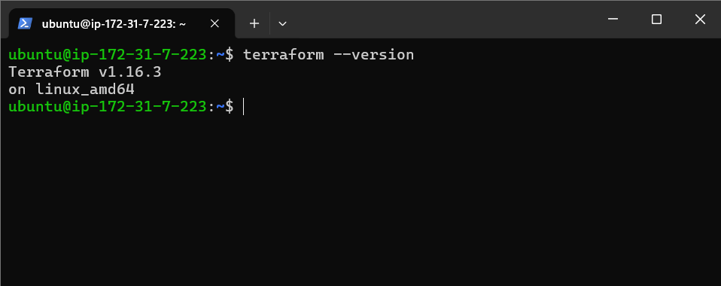

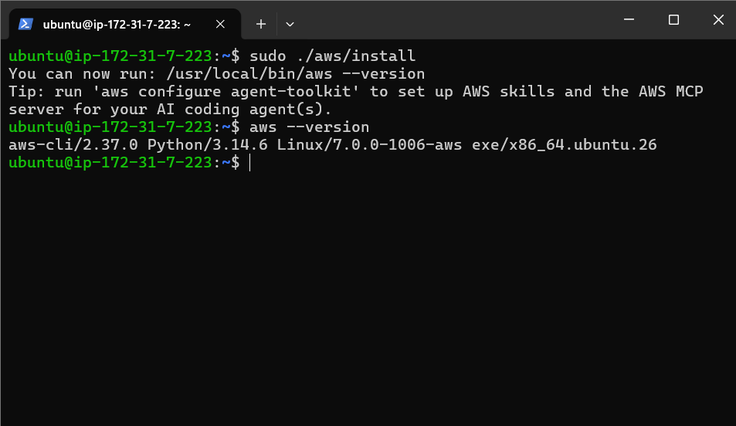

Install aws cli

curl "https://awscli.amazonaws.com/awscli-exe-linux-x86_64.zip" \
-o "awscliv2.zip"

sudo apt install unzip -y

sudo apt install unzip -y
unzip awscliv2.zip
sudo ./aws/install

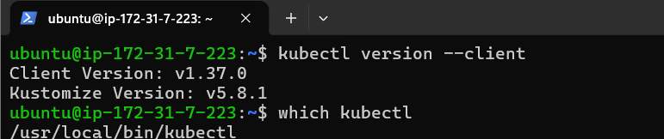

sudo apt install curl -y

curl -LO "https://dl.k8s.io/release/$(curl -L -s https://dl.k8s.io/release/stable.txt)/bin/linux/amd64/kubectl"

sudo install -o root -g root -m 0755 kubectl /usr/local/bin/kubectl

kubectl version --client

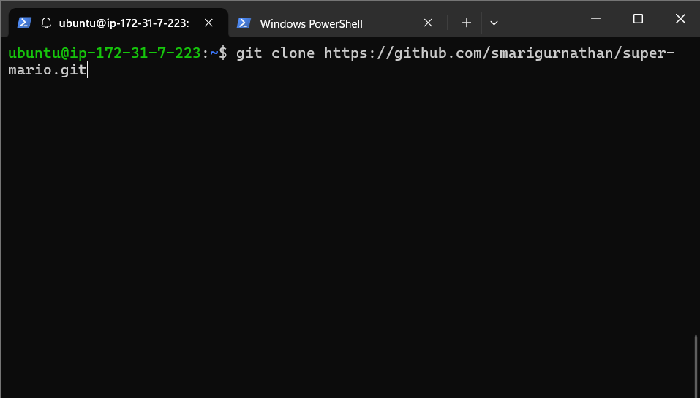

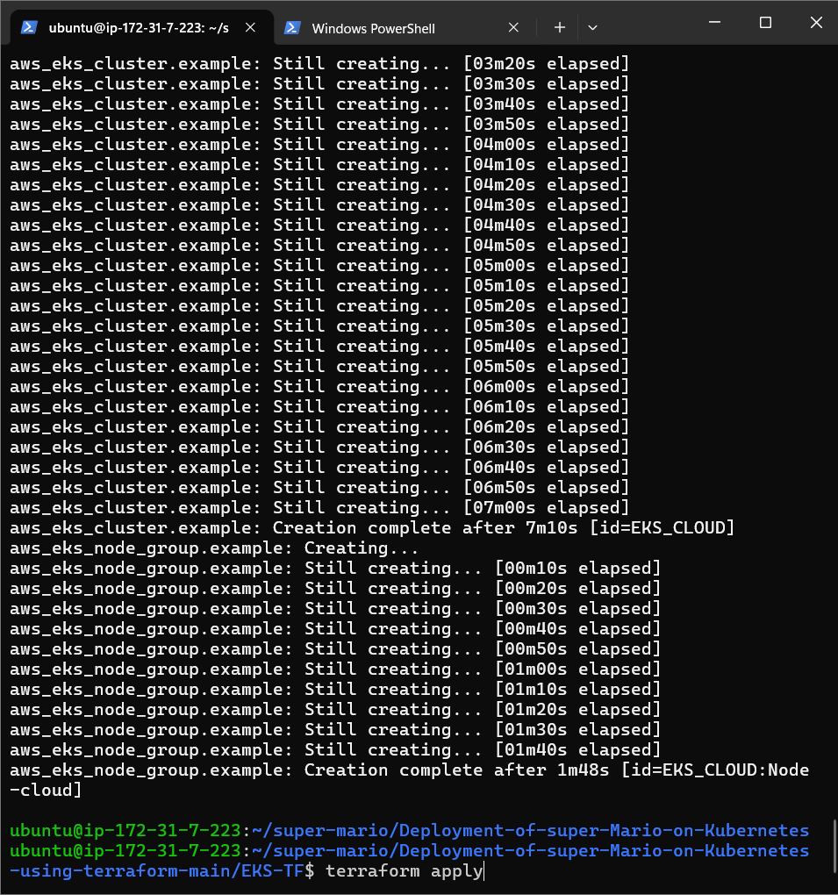

Eks created through terraform

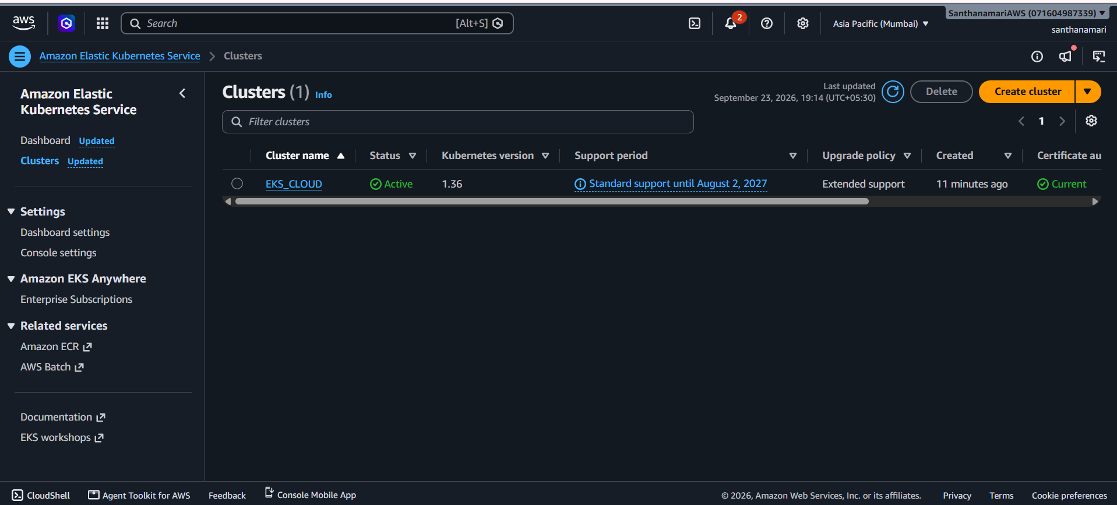

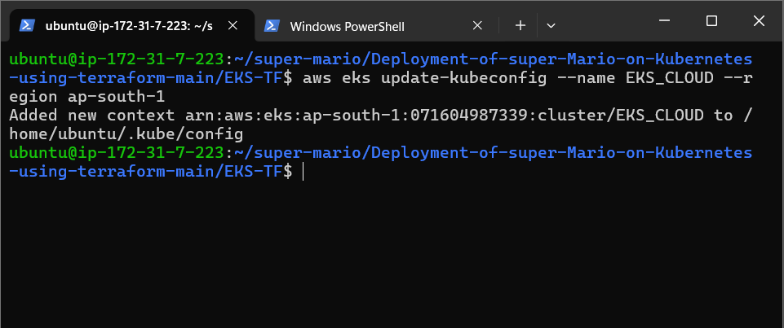

EC2 Ubuntu machine's kubectl is now configured to communicate with your EKS cluster.

aws eks describe-nodegroup --cluster-name EKS_CLOUD --nodegroup-name Node-cloud --region ap-south-1 this cmd mean

=> gets detailed information about an EKS managed node group.

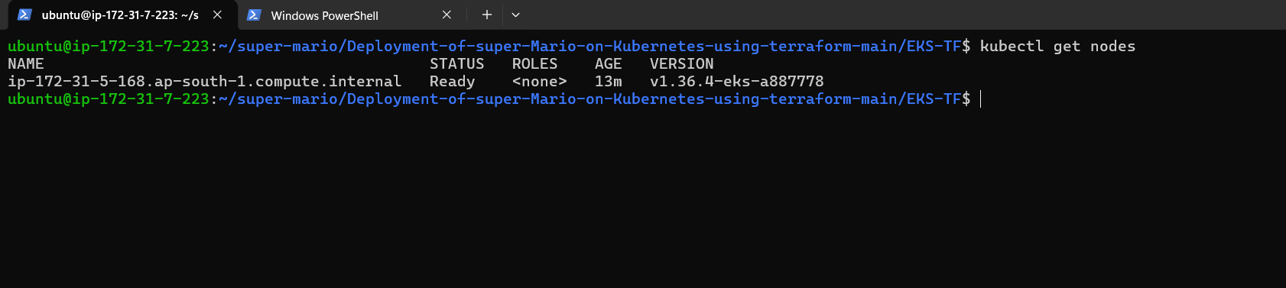

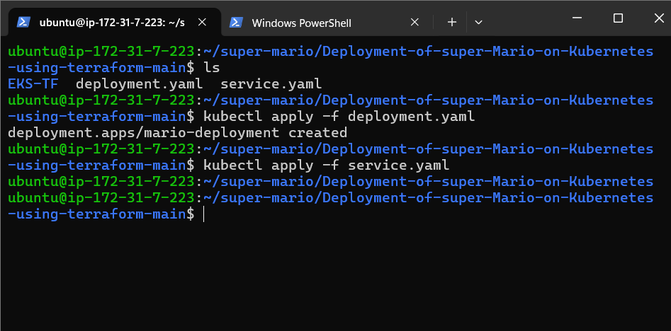

http://a7d9b57a1ecda4e528dc24a95e96e0db-1052908630.ap-south-1.elb.amazonaws.com/

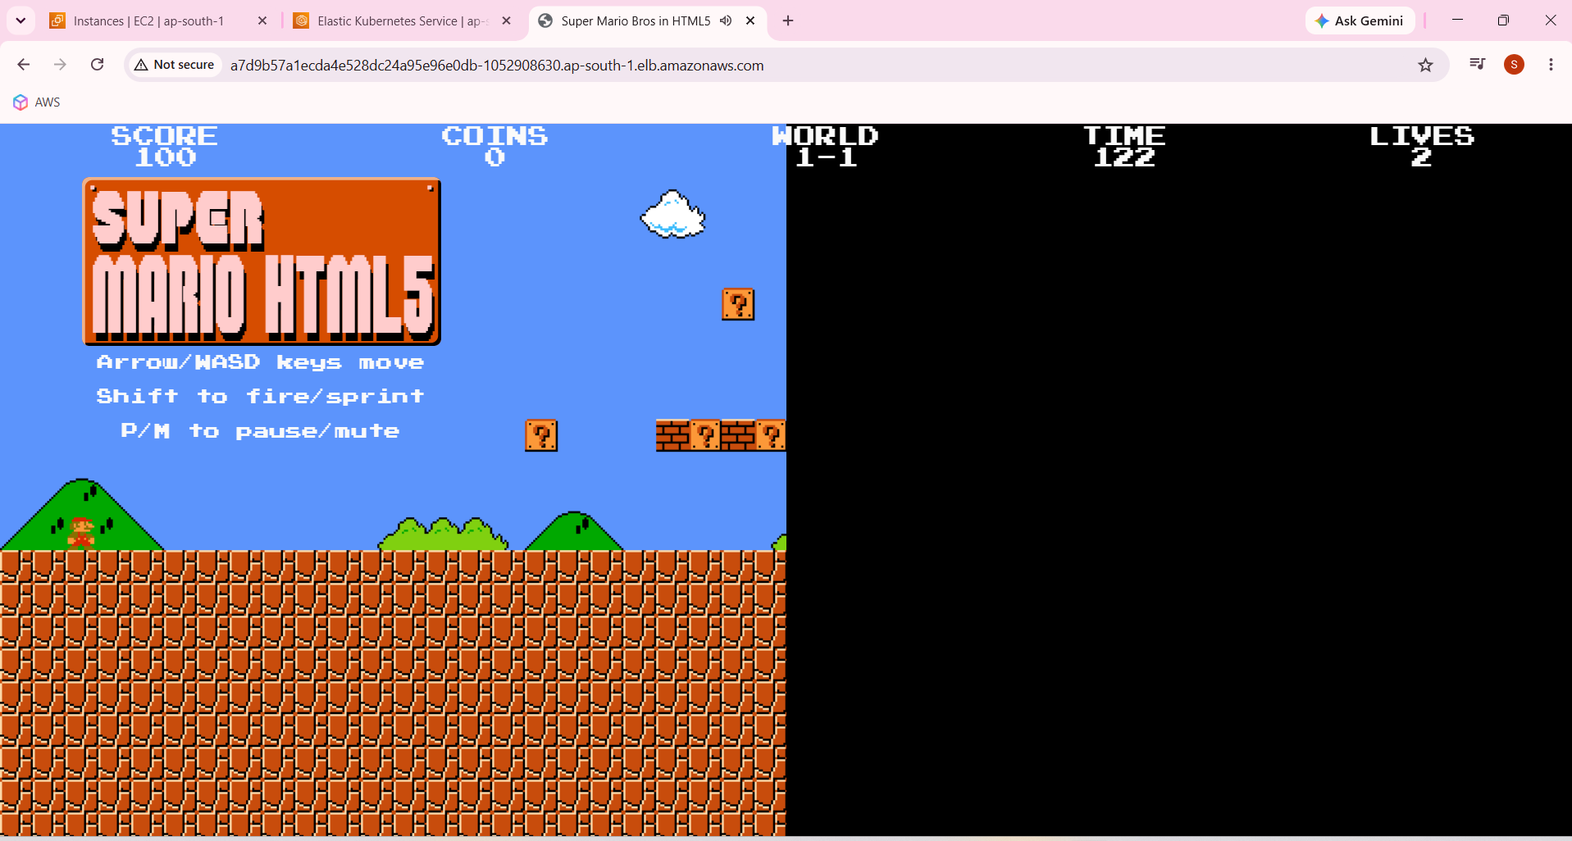

http://a7d9b57a1ecda4e528dc24a95e96e0db-1052908630.ap-south-1.elb.amazonaws.com/

Kubectl get svc
Kubectl get pods
____________________________________________________________________________

